RED ALERT - PRAYER NEEDED
August 10th, 2020
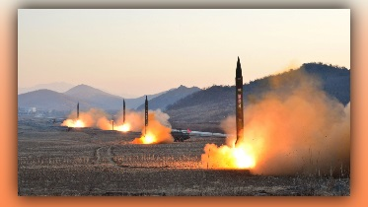
Heart Dwellers this is an alert! We are very close to a nuclear exchange. Please PRAY, PRAY, PRAY against this. Ezekiel had a dream but before I tell you about that, I want to tell you that we have heard a tremendous amount of military traffic going over head. We happen to be in a position where we are between two air force bases and we did hear a lot of traffic, at least since Friday.

So here is the dream, that some kind of really high-tech missiles were flying over the flat lands in our nation. I think they were being sent out, but they were incredibly high tech. They didn’t leave any kind of a trail and they had blazing white light coming out of the back of them. He also saw four different groups of air force jets flying in formation. In the dream, first came the jets, then the missiles. He’s also been getting a confirmation on that, again and again this morning. He had the dream a day and a half ago. Please, please pray that this will not have to necessarily happen, that God will intervene.

Thank you and God bless you family.

